**../../../../../../../Pictures/ARA/Pics/ARA%20LOGO/ARA%20master%20shield%20loKENT ACTIVE ../../../../../../../Pictures/ARA/Pics/ARA%20LOGO/ARA%20master%20shield%20lo**

**THE NEWSLETTER OF KENT ACTIVE RETIREMENT ASSOCIATION**

**Volume: Seven Summer 2021 No. 84**

***“Do not think of retirement as someone closing a door on a bright and crowded street.***

***Think of it as someone opening the door to a beckoning and uncluttered world.”***

**John Hardiman** *(Founder of the Association)*

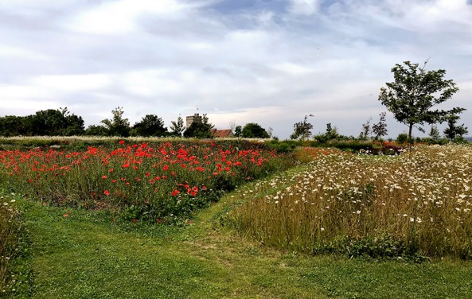

**Photograph by Graham Pover. Graham can be contacted at** [**gpoverphotography@btinternet.com**](mailto:gpoverphotography@btinternet.com)

**Dear Members,**

**I sincerely hope that you are all well, and filled with hope for the future.**

**Now that the lockdown has been lifted, many club committees are reconvening, and welcoming members back.**

**I have spoken to many Chairman, and Secretaries, and know that they have their members well-being at the heart of all they do, so a very sensible, and common sense approach in starting activities again is being taken.**

**We, the older generation see the wisdom of this approach, and will continue to wear masks, and use hand sanitizers when, and where appropriate. Social distancing may in certain younger circles, seem not to be quite so essential, but at club meetings it remains important to sit six at a table, and any member who wishes to keep their distance should be respected, and allowed to do so.**

**Below I have a date for your diary.**

**I hope this event can go ahead as planned, however, please be aware that it may have to be cancelled if the Government advise it.**

**It seems so long since we were able to come together as one big happy family.**

**The diary date is:**

* **Tea Dance, Friday 12th November 2021**

**This event is taking place at Ditton Community Centre.**

**Your Secretaries will receive details of these events shortly, and I hope this gives you all something to look forward to after eighteen months of lockdown. Once again, this all depends on the Governments guidance at the time of the event.**

**Also there is our KentARA Cruise which is scheduled for 14th September 2022. Places are still available, and we have new flyers for this special event, which are available to members interested in joining us.**

**Best wishes to you all.**

**Kind Regards,**

**Joan Rhodes**

**KentARA Chairlady**

**01732 844 953** [**rhodjo@aol.com**](mailto:rhodjo@aol.com)

***Up a Creek without a Paddle – But Where?***

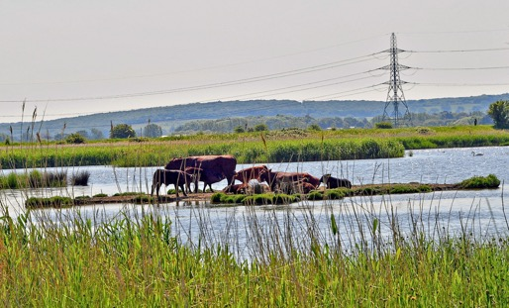

**Photograph by Graham Pover.**

1. ***Oare. b) The Ganges. c) UpChurch. d) Sun Pier, Chatham.***

***Answers to the Edita:*** [***ineverreadmyemails@nddontreply.com***](mailto:ineverreadmyemails@nddontreply.com)

**RamARA - Ramsgate**

**RamARA Club members have got off to an amazing start in late July.  It has been a wonderful opportunity to dust off the cobwebs, and to meet up with old friends.  It started with a 5-day break to Kendal.  All members wore face masks on the coach, but once at the Hotel we socially distanced, and with the excellent service from the staff, we all had a great time.**

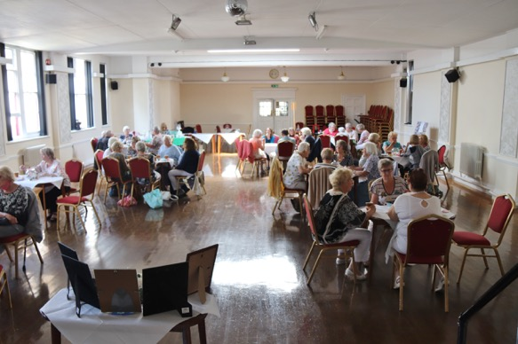

**The ‘RAMBUSTERS’.**

**Over a period of three days, starting mid-July, the Club commenced its meetings, (limiting numbers to 30 members at each gathering), where we required the confirmation of two jabs, the taking of temperatures, and the use of sanitisers.**

**Everyone was happy with the arrangements.**

**All the meetings started with a minute of silence in memory of those who have passed during our absence.**

***(N.B. The Table of Remembrance - bottom left).***

**We are now looking forward to a full meeting in August government willing! Frank Stocks (Chairman)**

**../../../../../../../Pictures/ARA/Pics/ARA%20LOGO/ARA%20master%20shield%20lo CANTICUM ACTUM ../../../../../../../Pictures/ARA/Pics/ARA%20LOGO/ARA%20master%20shield%20lo**

**THE ALTERNATIVE KENTARA NEWSLETTER**

**Volume: V11 Summer AD 2021 No. LXXX1V**

***“I Came, I Saw, I Cooked Pasta.”***

***Caesar Salada (Kitchen Despot)***

***Circulation: Friends, Romans, and Country Persons.***

**The KentARA Roman Legionnaires Re-enactment Group**

***The Annual Weekend Boot Camp at Duodenum Canticolon***

**A Cohort of 480 KentARA men, from all corners of the KentARA empire, descended on ‘Rough Common’ (just outside Canterbury), over the August Bank Holiday, to enjoy their annual Roman re-enactment weekend.**

**The acting Centurion, (John Marlowe, *aka. Maximus Minimus)*, who was responsible for scouting the site for the event, had unfortunately used an old archaeological reference book called, ‘The Ancient Maps of Roman Britain’, which although promising some 2000 years ago, proved somewhat out of date; as in the meantime the local council had built 1000 homes on it. In fact, all that remained of ‘Rough Common’ was a large green verge on a junction with the main road from Canterbury, which was just about big enough for a Roman square, half a dozen chariots made from pallets, and the Emperors gilded tent.**

**The bemused local residents soon turned ‘NIMBY’- *(Not In My Back Yard)*, when some 300 circling cars of KentARA Legionaries, (some driving in full costume, and ready for an early skirmish), took every available parking space in the area.**

**Signalling on his mobile trumpet, the KentARA Tribune *‘Pompous Arseus’*, mustered the Legionnaires onto the verge, and sounding like an unruly troupe of marching baking trays, they enthusiastically put on their aluminium foil covered cardboard armour. It smelt like Christmas, as the aroma from the recycled aluminium foil hinted at its previous use wrapping other turkeys.**

**However, just as the plastic Roman Eagle was being inflated, the local police arrived, represented by a bemused male sergeant, who looked as if this was just the type of incident that he didn’t want to handle some 30 minutes before the end of his shift.**

**Instantly, the officer pointed out that the Legionnaires long fixed bladed weapons were illegal, and would need to be confiscated. At this brave remark, a ripple of dissent was heard to rumble through the ranks of the KentARA Legionnaires, like some distant rolling thunder over the Apennine mountains.**

**The retired ‘chippy’ Malcolm, *(aka. ‘Bonkus Crackus’)* who was the chief armourer, invigorated by the unaccustomed interest shown in his whittling skills, said in excited tones not altogether suited to an occasion where humility floating on a sea of meekness would have been a much wiser strategy, declared that *“They are not weapons actually, they are ‘Swordlets”,* and additionally, *“Every great sword has a name - like Excalibur”...,* and that he had named his swordlet, *‘Gladys’*; which was a play on the word *‘Gladius’*, the Latin word meaning ‘Sword’.**

**The policeman glazed over.**

**However, Malcolm - or should I say, *‘Bonkus Crackus’,* now in full rhetorical flow – a new Cicero, continued his oratory saying, *“They are no match for a rolled up newspaper”,* and then, as if he had not already said too much, made the fatal tactical error of attempting humour, by adding a soupçon of sarcasm, and saying, *“In fact, up against your truncheon, they would snap like matchsticks”.***

**Just then, the ‘Emperor’ (Peter Longfellow, *aka. Biggus Discus),* hearing the ruckus from inside the regal tentus, exited his canvas palace to the sound of some unrehearsed bugger (he surely couldn’t be called a bugler), blowing a discordant fanfare, on what can only be described as an obscure looking horn, that resembled a stuffed python with a skin condition.**

**Accompanied by a small entourage of Pretorian guards, (four breathless centenarians from RoffARA), the Imperial party staggered forward against the straining leads of the legions two yellow wolves *-* a pair of rotund, ‘hippy’*,* and equally out of breath Labradors, called ‘*Romulus’,* and *‘Remus’.***

**The police sergeant who was by now, not only out ranked, but also out dressed, and outnumbered, became decidedly twitchy, and with only 15 minutes left before his shift finished, stated in no uncertain terms, that the whole gathering must immediately disperse, or face being deported on the next Roman galley to Calais. Can you imagine the Gaul of it!**

**Luckily for him, one of the KentARA Legionnaires was an ‘old boy’ of a local school, and after a quick pull of a string, and a short visit in his chariot (Fiat 126) to a nearby playing field; saw everyone decamp to enjoy a weekend undisturbed by the local residents, or Constabulary.**

**That was until Sunday, when a large contingent of suitably ragged looking ‘KentARA Britons’ arrived to re-enact the ‘Battle of Tomas Hill’ – where apparently the Romans took a pasting from the Britons, under their Queen ‘Rhodercea’.**

**Next year Londinium.**

***Report submitted by ‘Frivolous Fartus’ of DurobrivaeARA.***

***Joke***

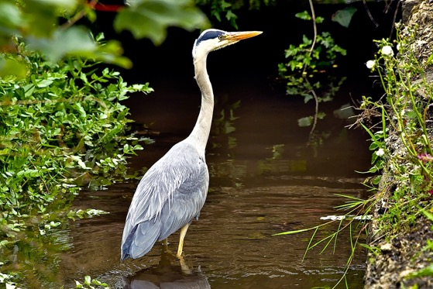

**Photograph’s by Graham Pover.**

***It doesn’t pay to be Koi.***